**Sign Language To Speech Conversion**

**~Submitted by**

### **Team Members**

1. M Shiva Sathwik (21911A3533)
2. M Shivaram (21911A3535)
3. M DeviManognya (21911A3536)
4. M Vaishnavi (21911A3537)

### **Introduction**

Communicating through hand gestures is one of the most common forms of non-verbal and visual communication adopted by speech-impaired populations all around the world. The problem existing at the moment is that most people are not able to comprehend hand gestures or convert them to enough for the listener to understand.

A large fraction of India’s population is speech impaired. In addition to this communication to sign language is not a very easy task. This problem demands a better solution that can assist the speech-impaired population in conversation without any difficulties. As a result, it reduces the communication gap for the speech impaired.

Sign language is an essential form of communication for individuals with hearing impairments. However, it can be challenging for those who don’t understand sign language to communicate effectively with sign language users. To bridge this communication gap, we can use technology to convert sign language gestures into audible speech. In this article, we will explore how to build a sign language-to-speech conversion system using Arduino, a flex sensor, and a 16×2 LCD with I2C

### **Components**

1. Flex sensor
2. Arduino Nano
3. DF Mini Player
4. Speaker
5. Zero PCB

### **Circuit Diagram**

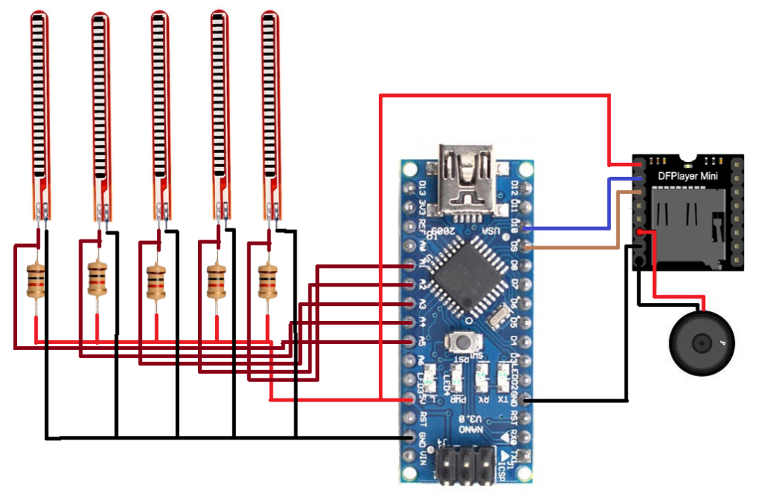

### **Source Code**

**For Raw value In Serial Monitor**

const int flexPin = A1;

void setup() {

  Serial.begin(9600);

}

void loop() {

  int flexValue;

  flexValue = analogRead(flexPin);

  Serial.print("sensor: ");

  Serial.println(flexValue);

  delay(20);

}

**Code for all the flex sensors:**

#include "SoftwareSerial.h"

#include "DFRobotDFPlayerMini.h"

DFRobotDFPlayerMini myDFPlayer;

void printDetail(uint8_t type, int value);

unsigned int f;

SoftwareSerial mySoftwareSerial(9,10);

void setup()

{

  Serial.begin(9600);

  mySoftwareSerial.begin(9600);

  Serial.println();

  Serial.println(F("Initializing DFPlayer..."));

  if (!myDFPlayer.begin(mySoftwareSerial)) {

    Serial.println(F("Unable to begin:"));

    Serial.println(F("1.Please recheck the connection!"));

    Serial.println(F("2.Please insert the SD card!"));

    while (true);

  }

  Serial.println(F("DFPlayer Mini online."));

  myDFPlayer.volume(30);

}

void loop()

{

  f = analogRead(1);

  Serial.println(f);

  if (f > 320)

  {

    Serial.println("Please Give Me Water");

    myDFPlayer.play(1);

    delay(1000);

  }

  else if ((f < 320) && (f > 280))

  {

    Serial.println("Please Give Me Food");

    myDFPlayer.play(2);

    delay(1000);

  }

  else if ((f < 200) && (f > 100))

  {

    Serial.println("Give Me Water");

    myDFPlayer.play(3);

  delay(1000);

  }

  else

  {

    if (f > 100)

  }

  delay(50);

}

### **Procedure:**

* Connect the +5V pin of the Arduino to the +5V pin of the Flex Sensor and DF Mini Player.
* Connect the GND (ground) pin of the Arduino to the GND pins of the Flex Sensor and DF Mini Player.
* Connect the analogue output pin (A0) of the Flex Sensor to the A0 pin of the Arduino.
* Connect the digital pins D9 and D10 of the Arduino to the TX and RX pins of the DF Mini Player, respectively.
* Connect the +5V and GND pins of the DF Mini Player to the +5V and GND pins of the Arduino.
* Connect digital pins D2, D3, and D4 of the Arduino to the Blue, Green, and Red LEDs, respectively.
* Connect the Speaker/Headphones to the audio output jack of the DF Mini Player.